This is a follow up after working intervlan routing,hsrp and ethernet channel.
Setting up ip for management of wlc
ip add 192.168.70.5
/24 net
192.168.70.1 gateway

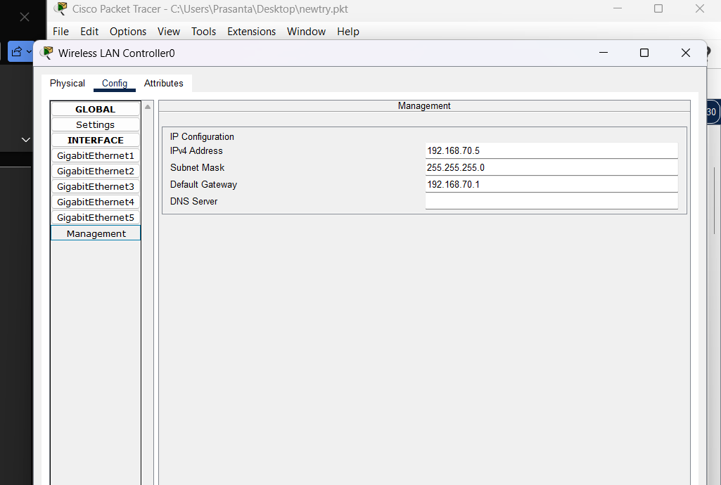
Accesing web interface from any pc in internal network as upto now no access list is configured and so I will take management pc
Navigate to web browser and type http://192.168.70.5 ,
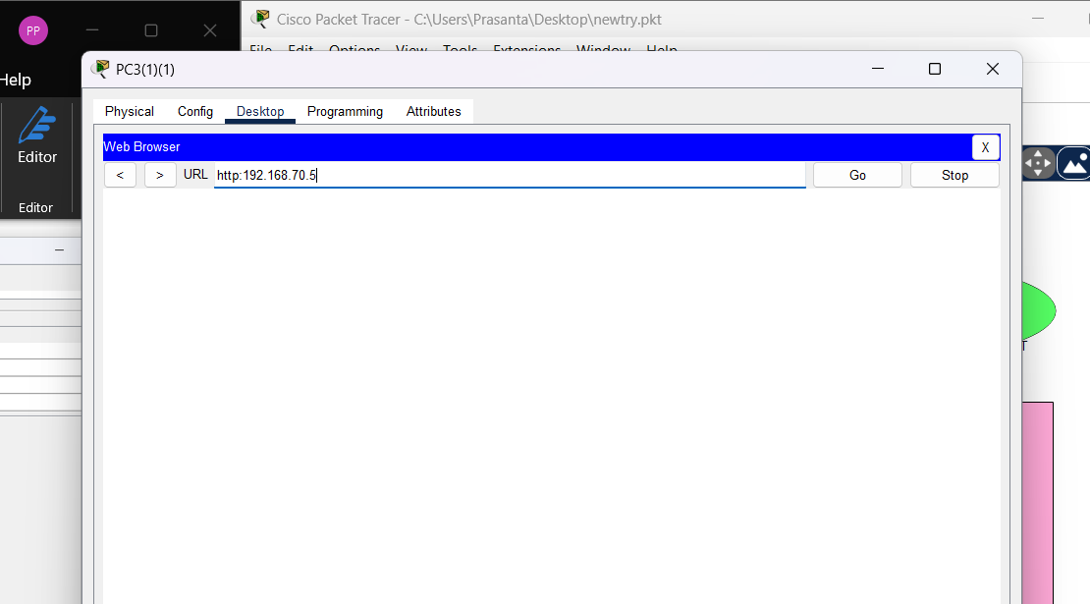
Create admin username and password,
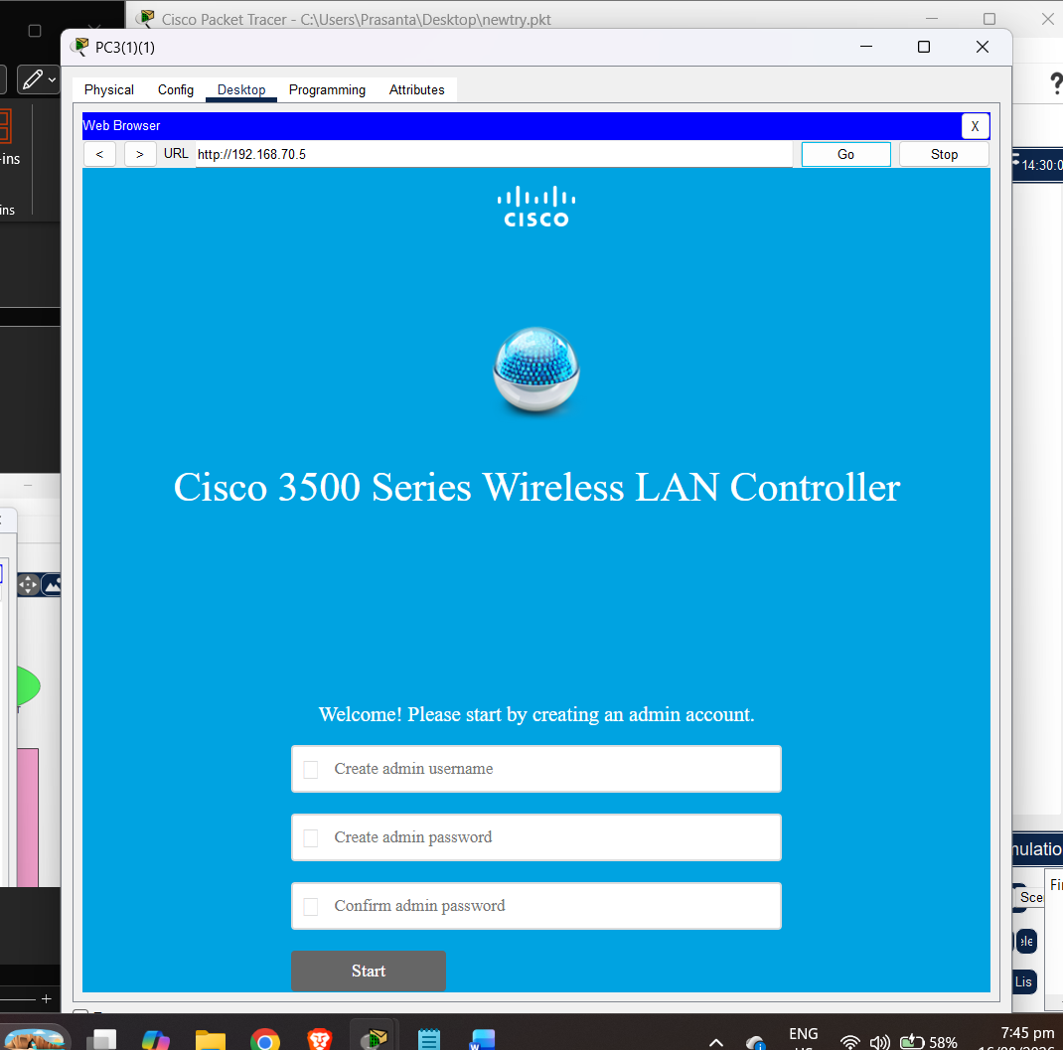
My admin name prasanta
password Project@1234
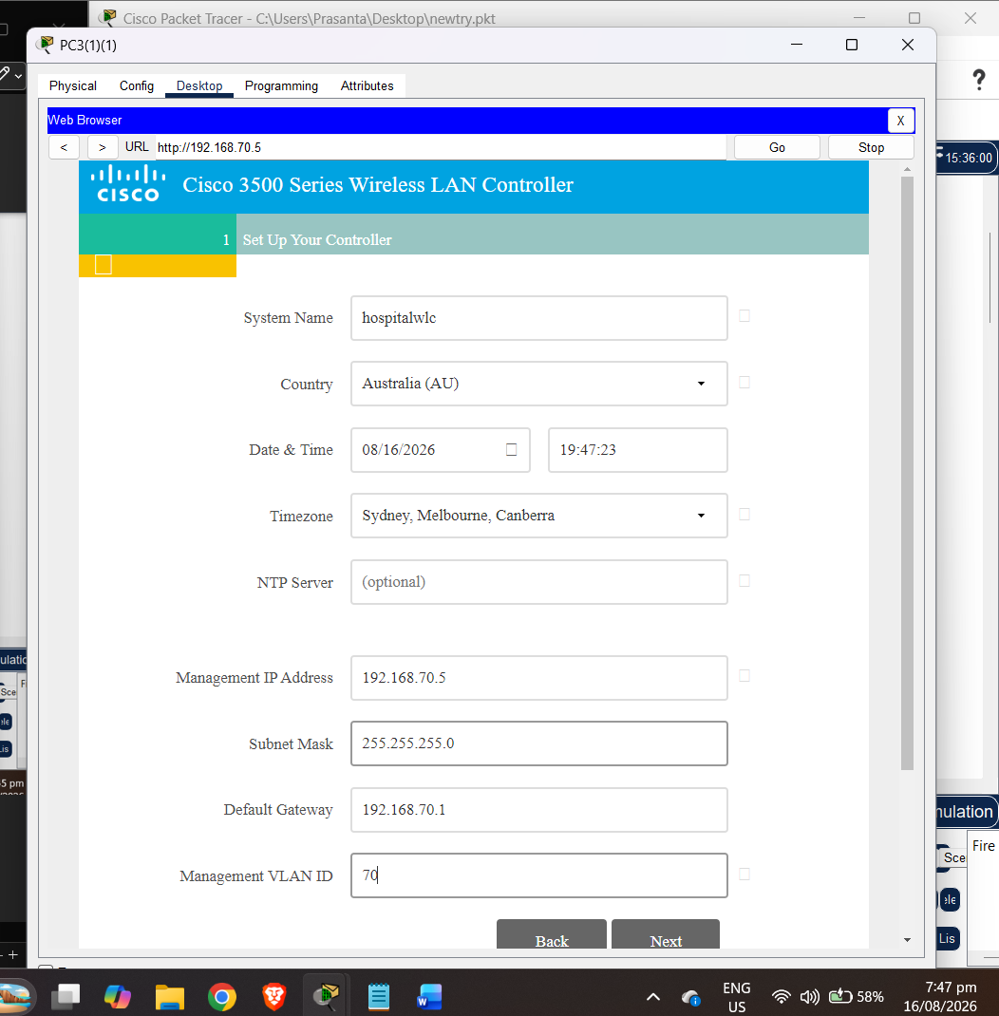
Fill up these management and system setup,
Employee network
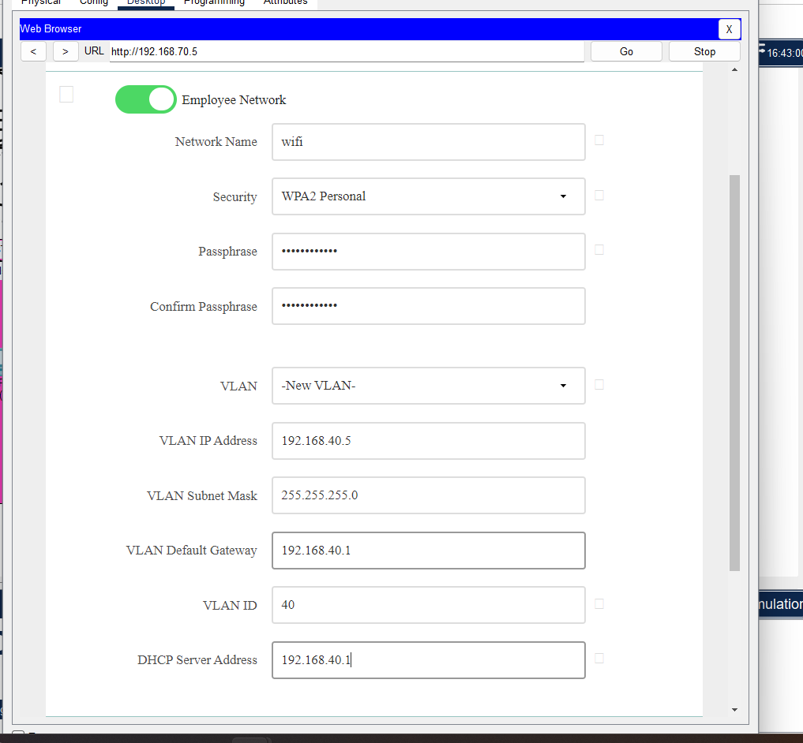
and leave default for this,
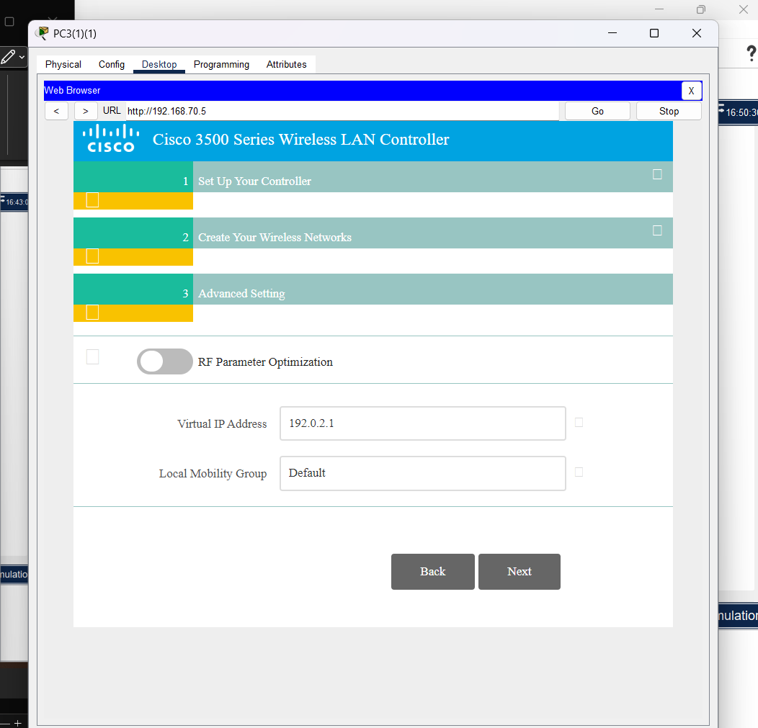
Verify and doublecheck details,
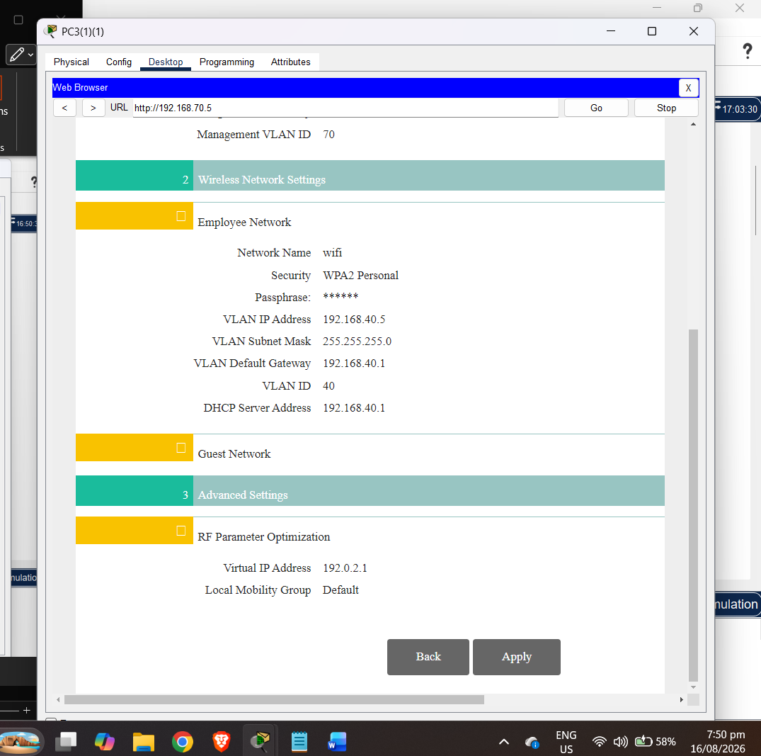
Press apply and click ok,
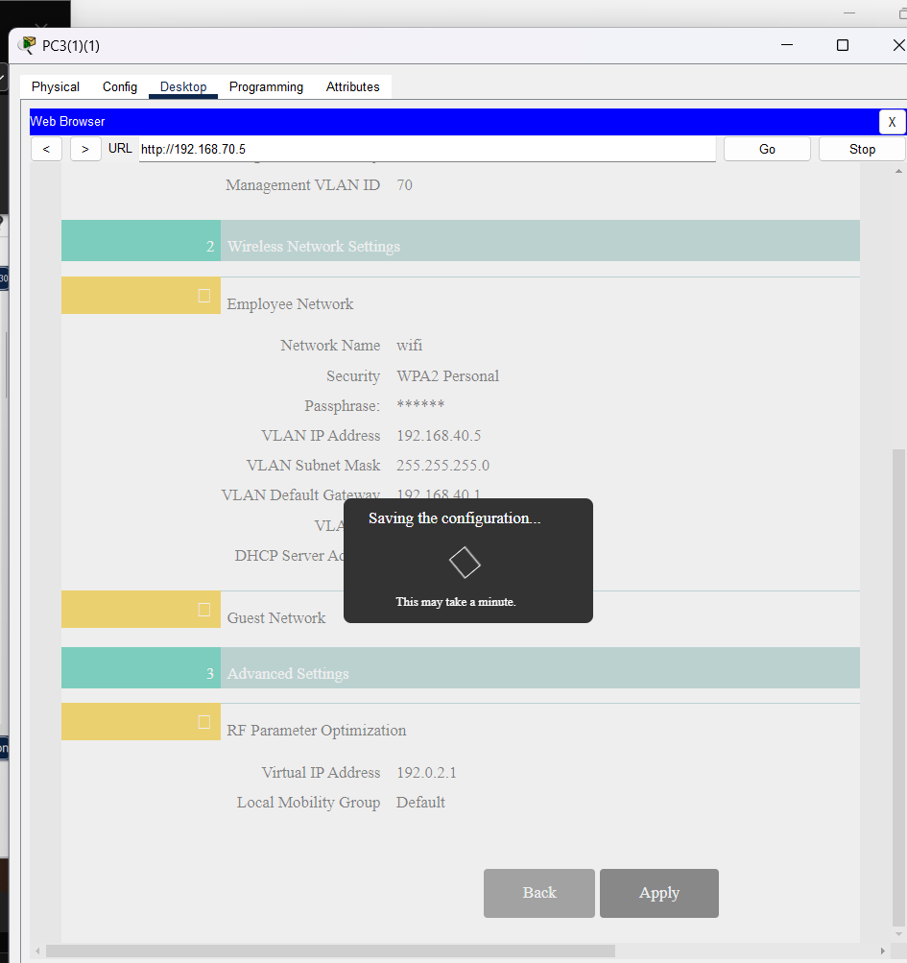
wait for a while ,
just change http to https same address,
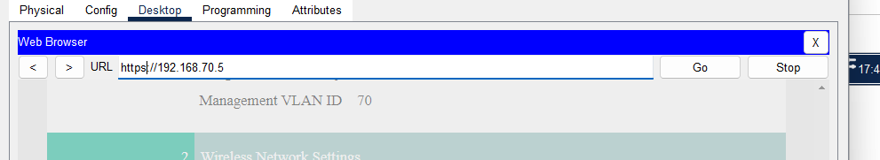
Now login with admin username and password created,
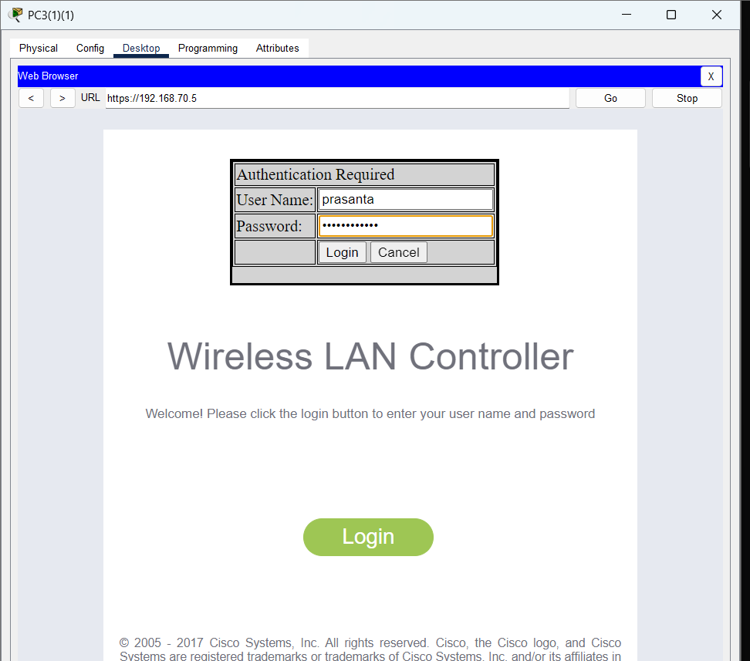

Now go to controller<interfaces and create new interface for me is wifi interface and guest wifi,
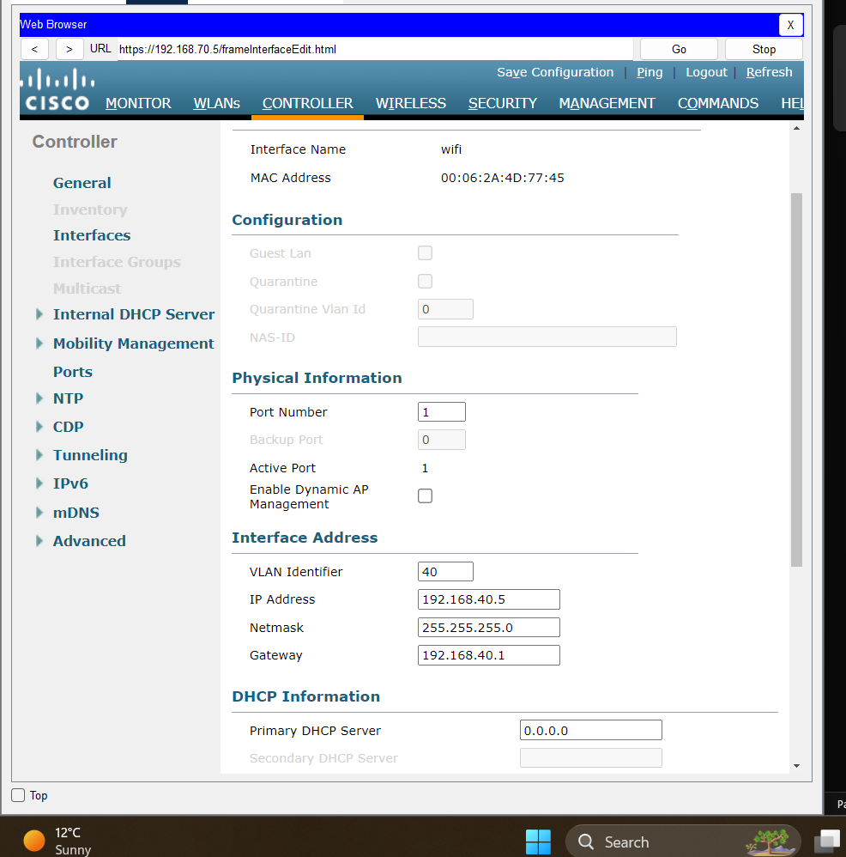
I keep 0.0.0.0 for dhcp as dhcp is resolved from multilayerswitch so keep default here,
Fill exactly like this as my vlan 40, port is one connected from wlc to access switch,
Same for guestwifi, vlan 50 , port 1,192.168. 50.5 ip interface, /24 network 50.1 hsrp virtual gateway. Click apply,

Now go to wlan and create new click go
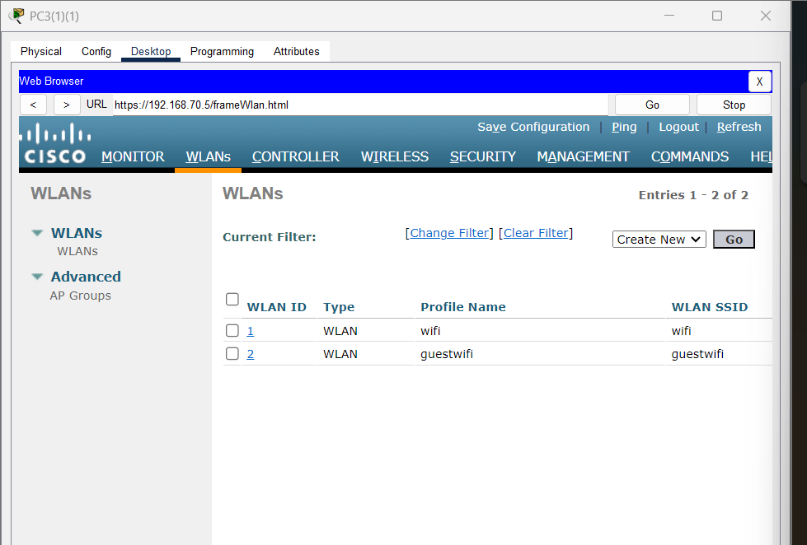
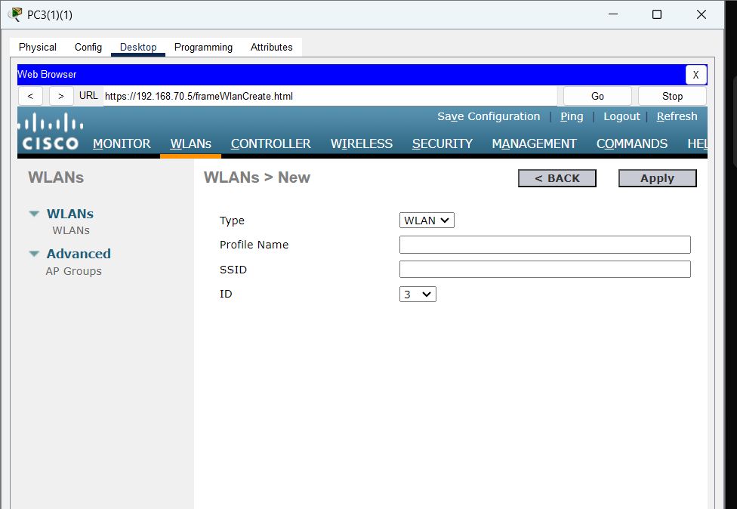
Fill up these, mine will be wifi for internal staff,
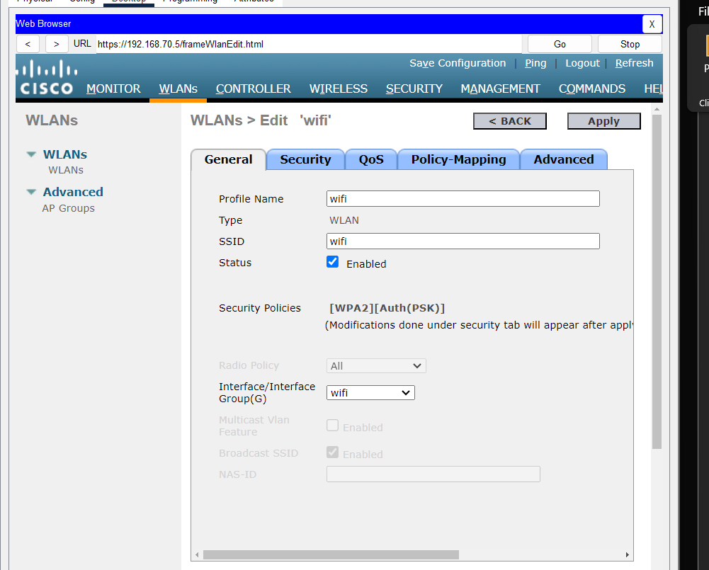
status enbled, put in creted wifi interface,
Security tab click wpa +wpa2 and wpa2 policy psk
and create passphrase for it mine is Wifi@1234 for wifi ssid and for guestwifi it will be
Guestwifi@1234
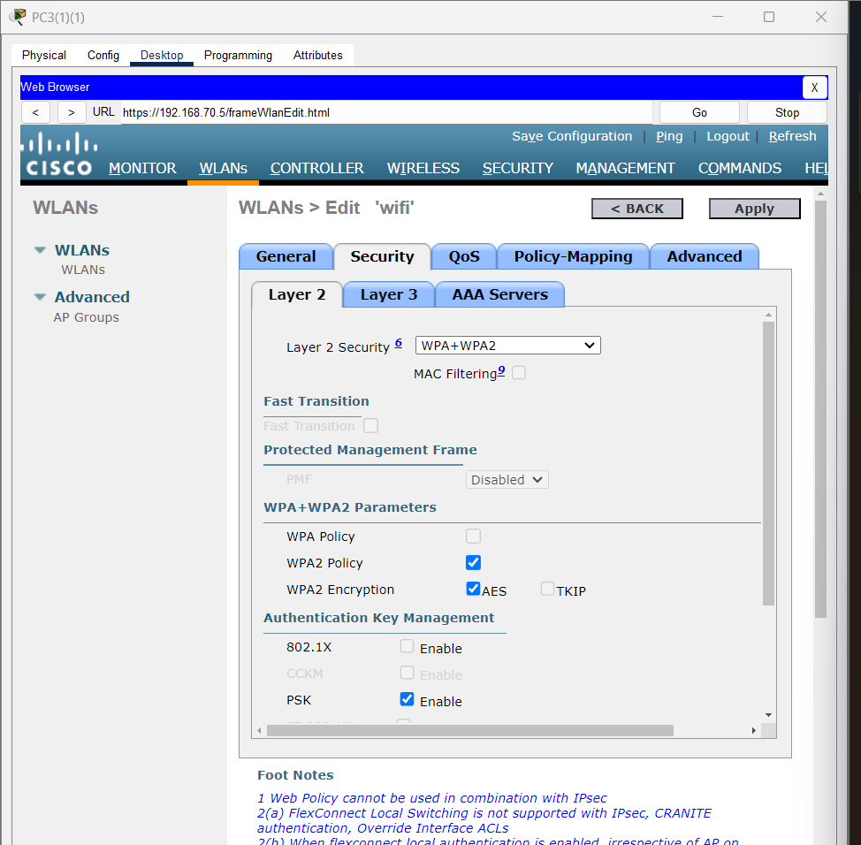
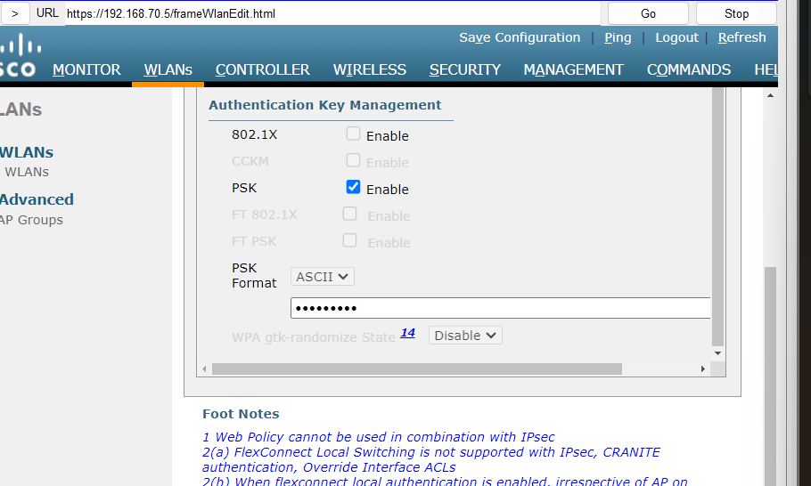
Now we need to enbled flexconnect for our network topology as it wont work through normal default mode,
Go to advanced,
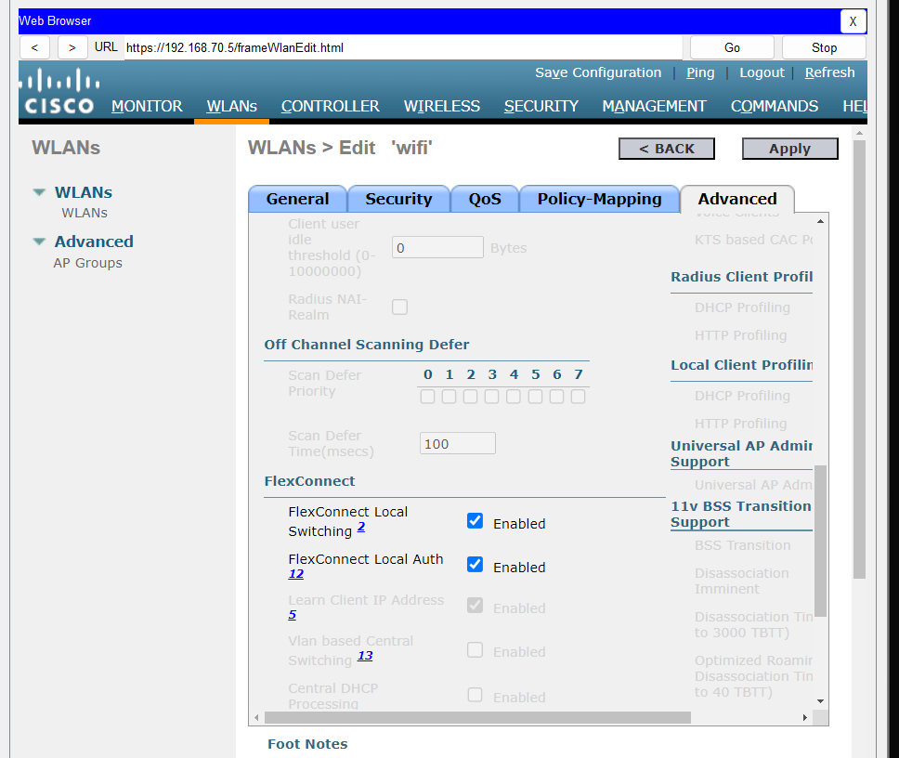
Now just create ap group name wifi and guest wifi and put wlan and ap there put right wlan and ap order.
Its in WLAN check left side and click ap group,
Now add group,
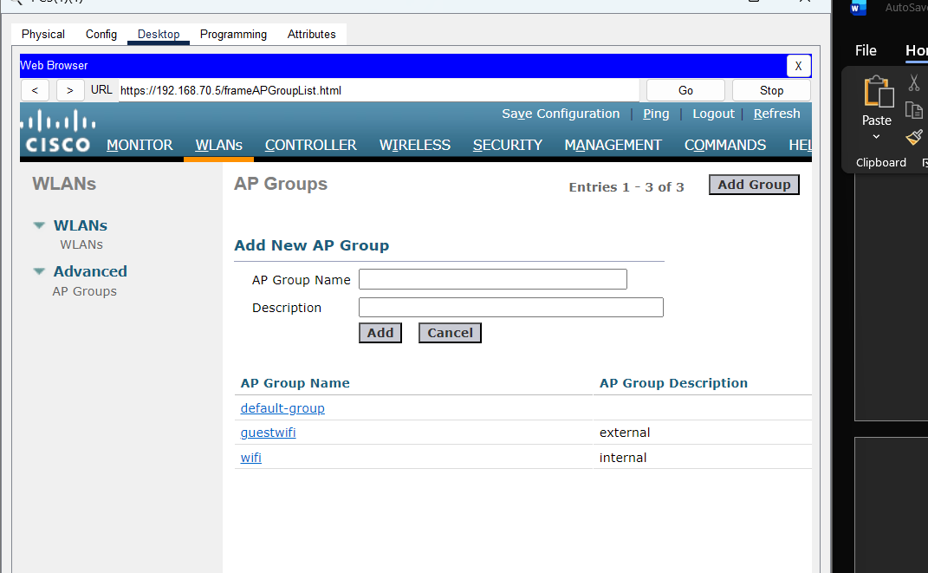
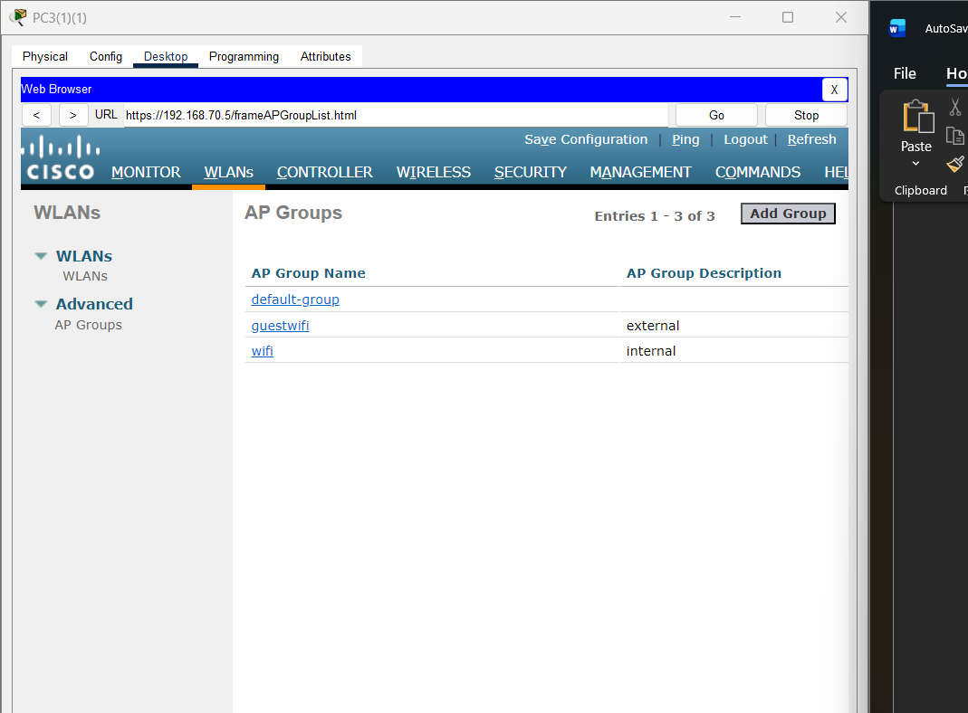
After adding put wifi ssid wlan inside wifi ap group created also wifiap in ap and apply,
Same goes with guestwifi,
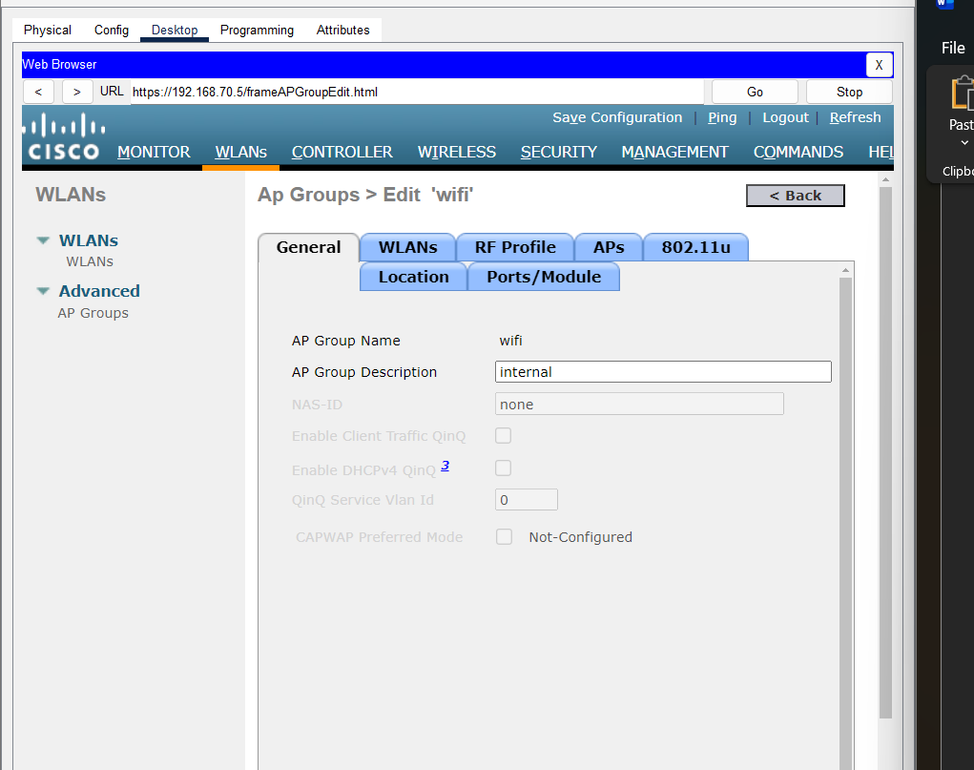
Click from add new to add wlan
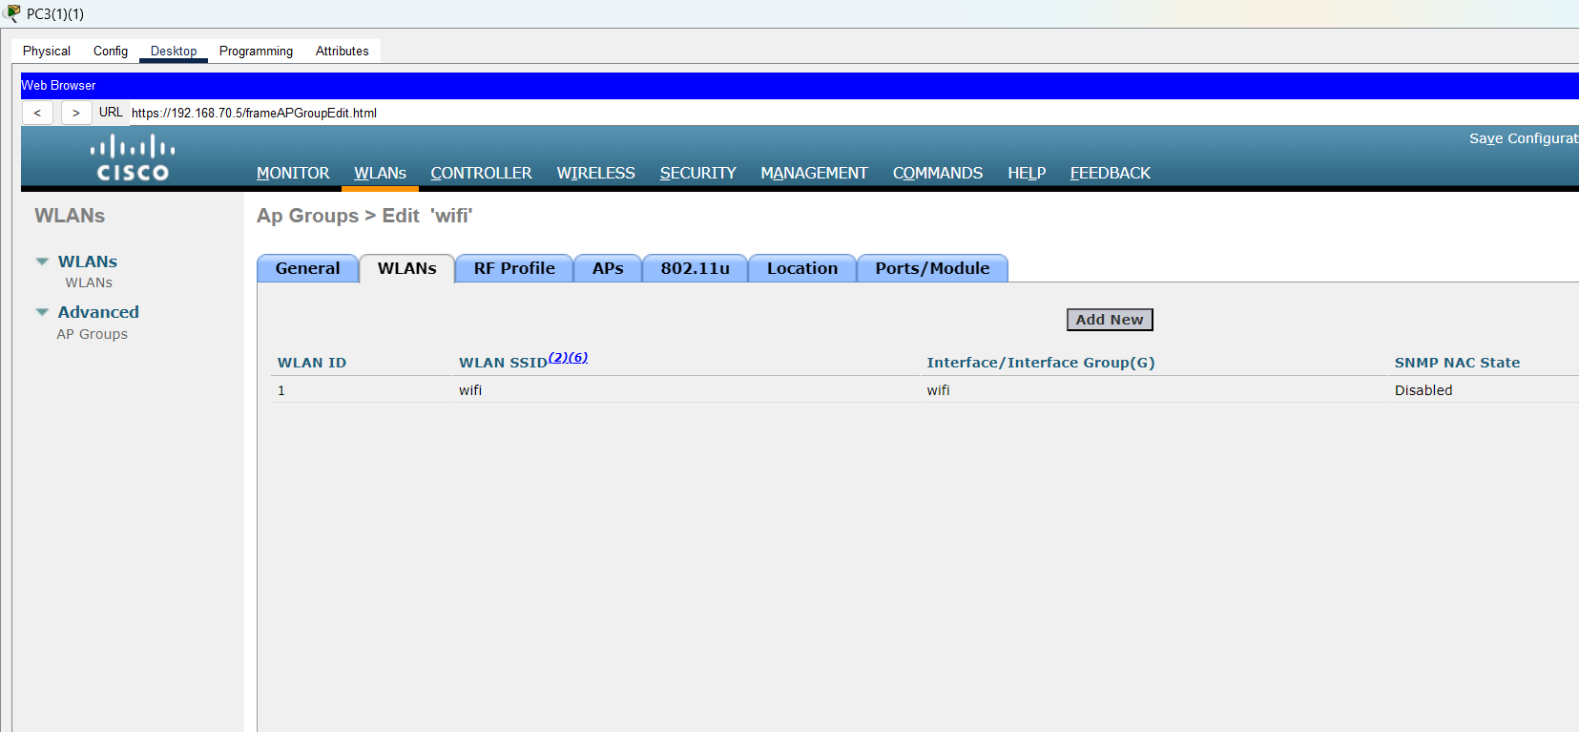
Now for ap check wifi ap and press add
now apply,
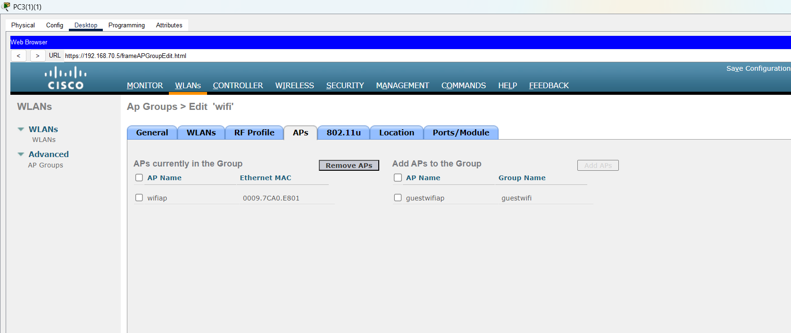
After applying for both done now lets connect end devices,
For laptop you need to trun off first so you can remove one adapter from it in physical tab and add wpc300n network adapter for wifi,
and power back on same goes with pc,
Navigate to config fill up in wireless 0
SSID wifi wpa2psk security layer you created and passphrase you choosed while creating WLAN, for me its wifi(wlan) passphrase is Wifi@1234.
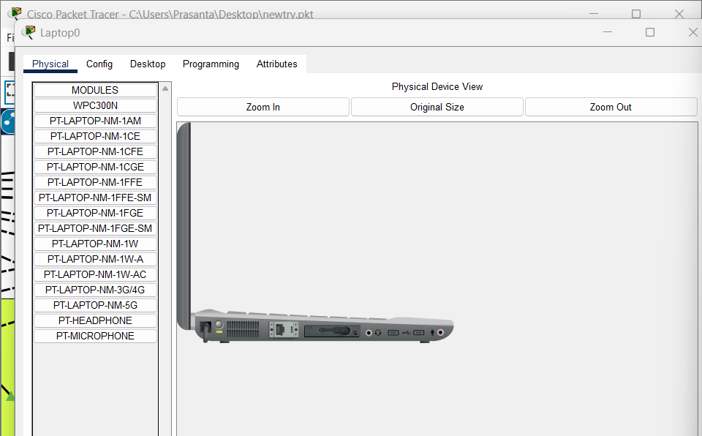
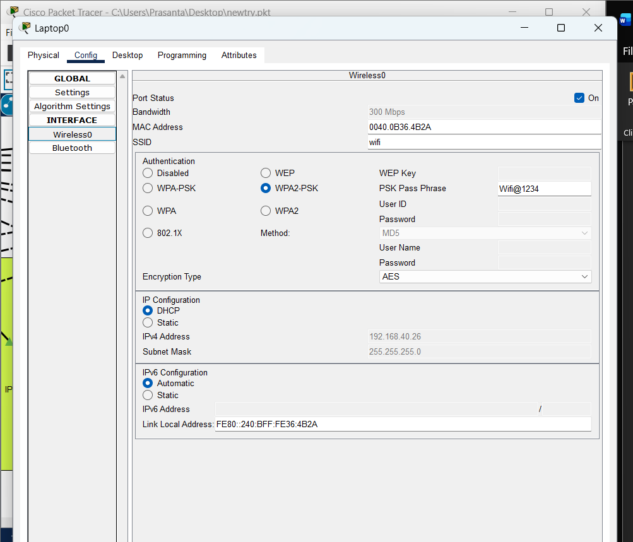
even after this it wont connect than go to pc wireless in desktop tab,
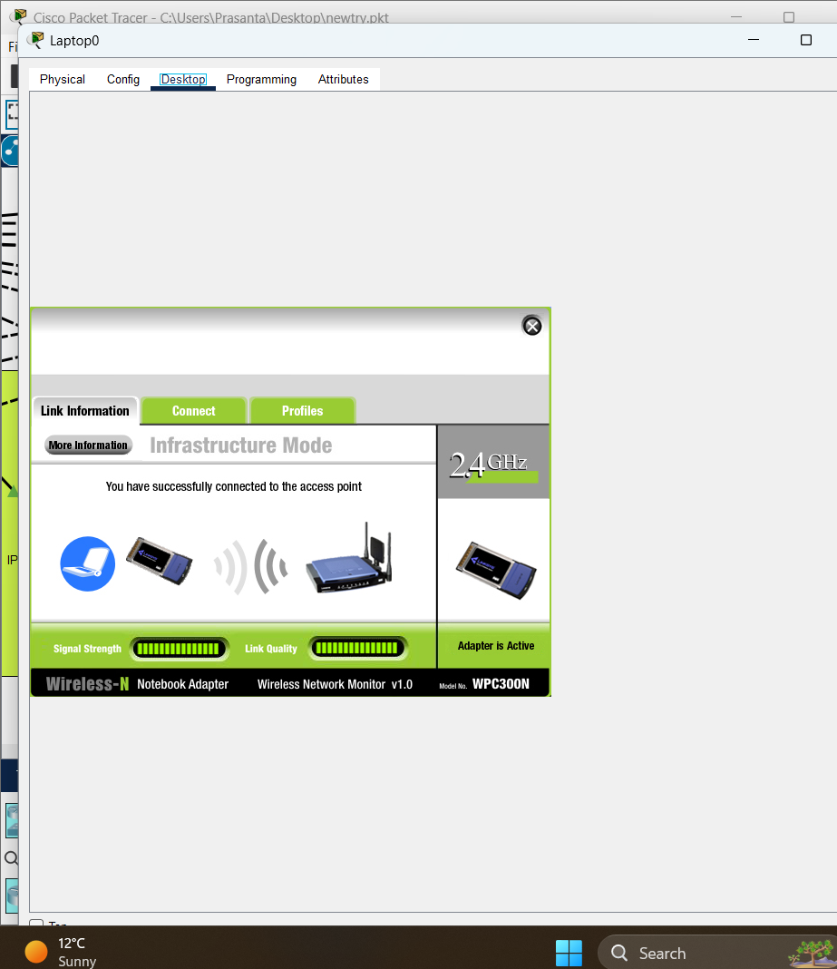
here you can see ssid to connect and connect with passphrase you created done .
As mine is already connected so,
Similar process for guestwifi or any wifi ap you want to add in your network .

